**CHAPTER THREE**

SYSTEM DESIGN

In this chapter, we will discuss the database and table schemas and how the different tables are related to one another seamlessly to perform efficiently, the database schema follows all the normalization processes to the latter and thus system performance is enhanced.

The system maintains data integrity in all of its table designs.

3.1 DATABASE **TABLE SCHEMA & DESIGN**

VARIOUS TABELS TO MAINTAIN INFORMATION

1. 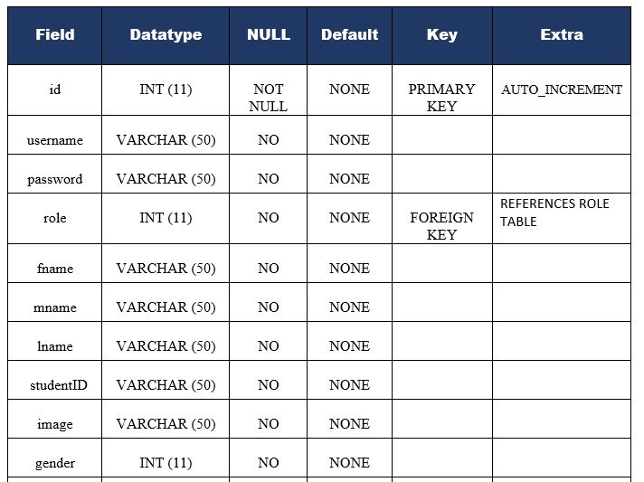ADMIN TABLE FOR SYSTEM ADMINS

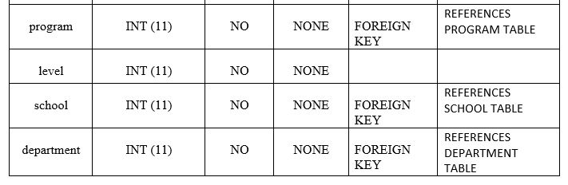

1. 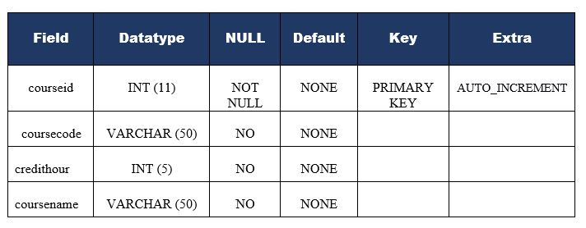TABLE FOR STORING INFORMATION ON COURSES
2. 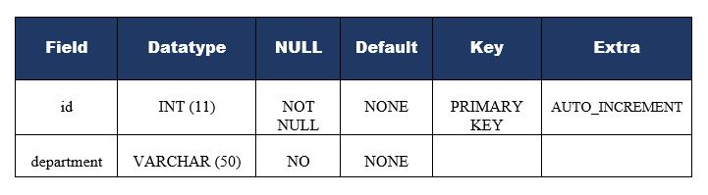TABLE FOR STORING INFORMATION ON DEPARTMENTS

1. 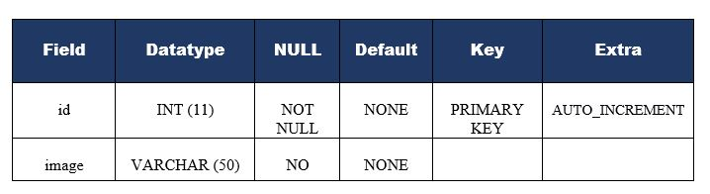TABLE FOR STORING GALLERY INFORMATION
2. 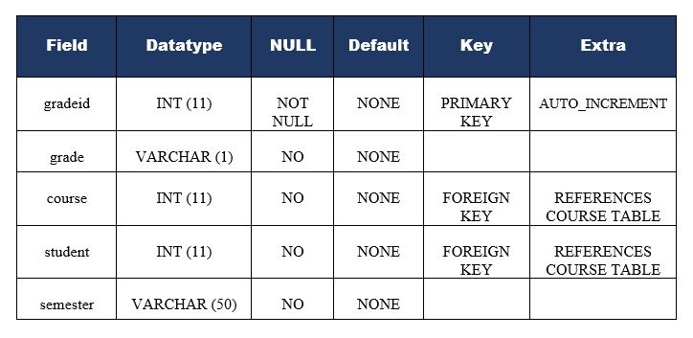TABLE FOR STORING STUDENTS GRADES
3. 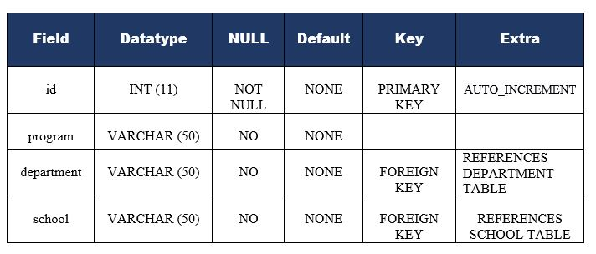TABLE FOR STORING PROGRAM INFORMATION
4. TABLE FOR STORING STUDENT REVIEW INFORMATION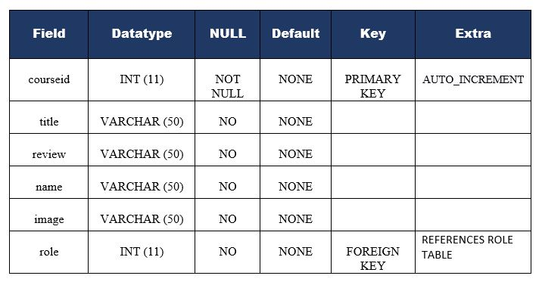
5. 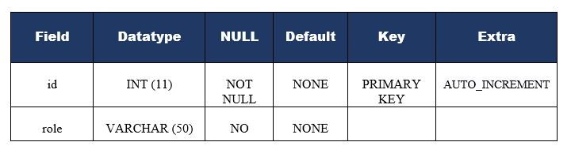TABLE FOR STORING USER ROLE
6. 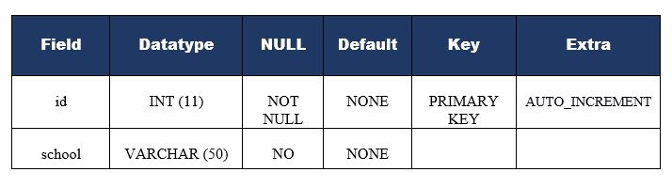TABLE FOR STORING SCHOOL INFORMATION
7. TABLE FOR STORING SLIDER INFORMATION



**3.2 DATA FLOW DIAGRAMS**

1. DATA FLOW DIAGRAM FOR SUPERADMIN LOGIN

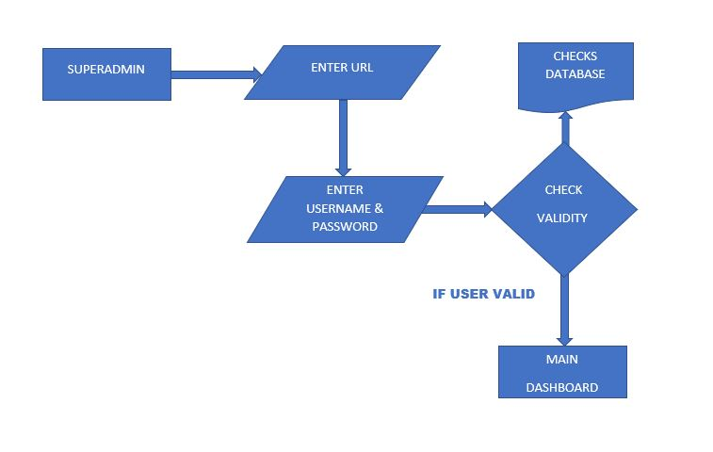

After entering the home page of the website, Super - admin can choose the LOGIN option where they are asked to enter username & password, and if he/she is a valid user then they will be redirected to the main dashboard.

1. DATA FLOW DIAGRAM FOR SCHOOL ADMIN LOGIN

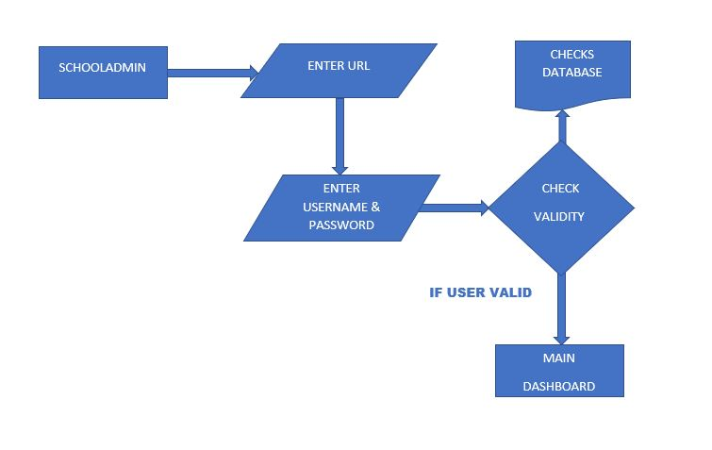

After entering the home page of the website, School - admin can choose the LOGIN option where they are asked to enter username & password, and if he/she is a valid user then they will be redirected to the main dashboard.

1. DATA FLOW DIAGRAM FOR DEPARTMENTAL ADMIN LOGIN

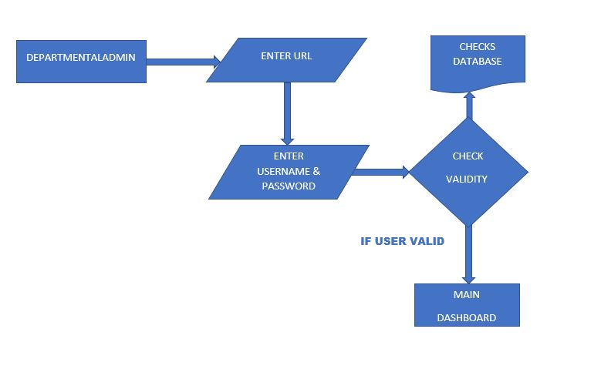

After entering the home page of the website, Departmental - admin can choose the LOGIN option where they are asked to enter username & password, and if he/she is a valid user then they will be redirected to the main dashboard.

1. DATA FLOW DIAGRAM FOR LECTURER LOGIN

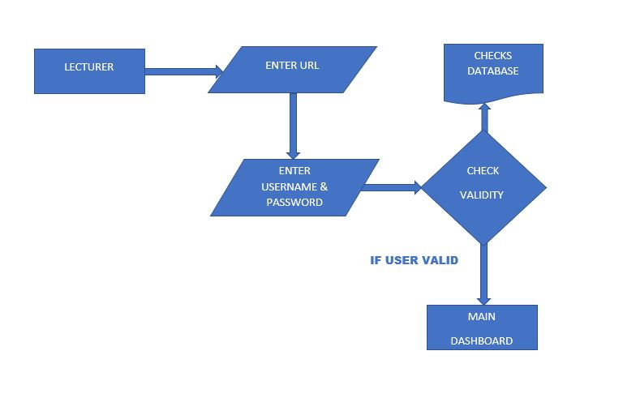

After entering the home page of the website, Lecturer - admin can choose the LOGIN option where they are asked to enter username & password, and if he/she is a valid user then they will be redirected to the main dashboard.

1. DATA FLOW DIAGRAM FOR STUDENT LOGIN

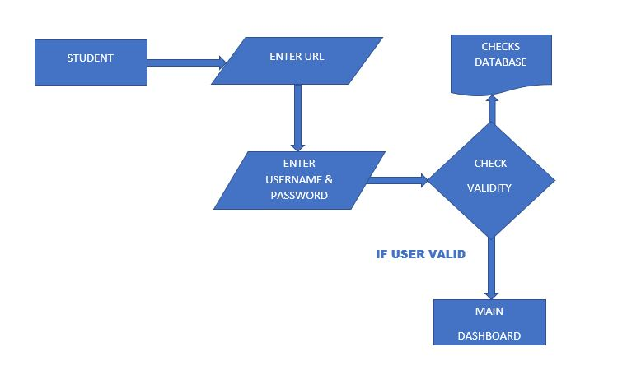

After entering the home page of the website, Student can choose the LOGIN option where they are asked to enter username & password, and if he/she is a valid user then they will be redirected to the main dashboard.

1. DATA FLOW DIAGRAM FOR LECTURER ADDING STUDENT GRADES

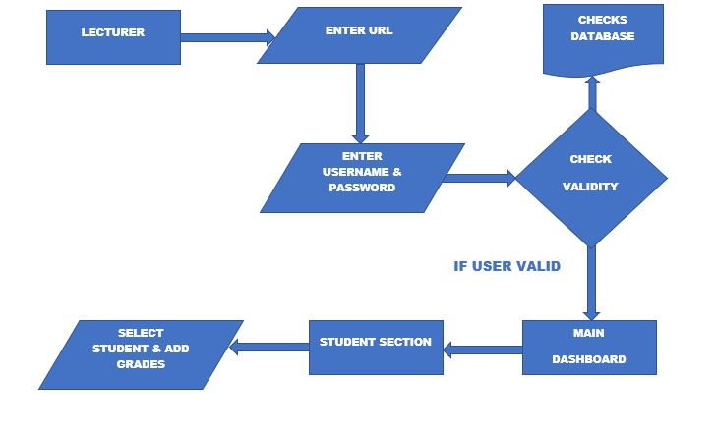

After entering the main dashboard of the website, Lecturer can now add student grades based on courses selected by student.

1. DATA FLOW DIAGRAM FOR LECTURER ADDING STUDENT NOTES

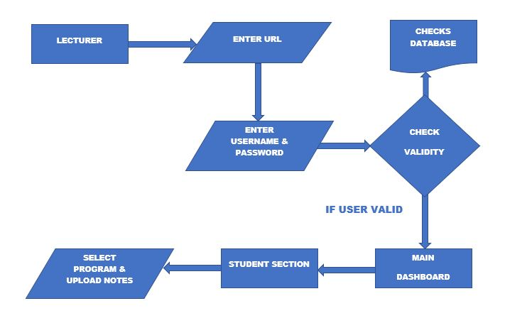

After entering the main dashboard of the website, Lecturer can now add the student notes based on courses selected by student and their various semester.

1. 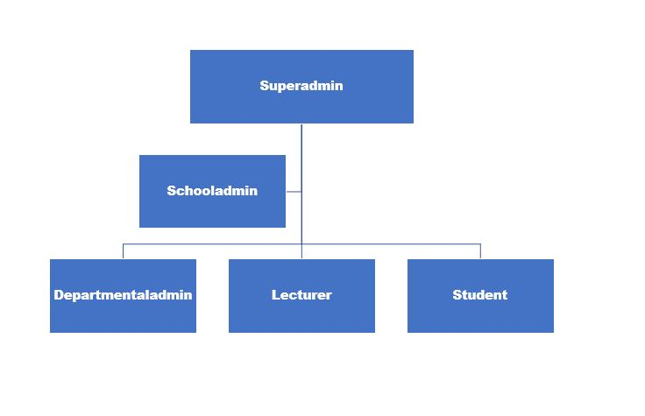DATA FLOW DIAGRAM OF THE ENTIRE SYSTEM USER LEVE

Summary of the entire user level and privileges of the system.